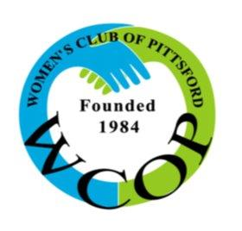
A non-profit 501 C (3) service organization

Women’s Club of Pittsford
PO Box 208
Pittsford, NY 14534

July, 2019

Dear

On October 17, 2019, the Women’s Club of Pittsford will host our annual “BUNCO FOR CHARITY” night at Midvale Country Club. This is our club’s MAJOR fundraiser and the proceeds raised will support local non-profit organizations.

For over 35 years, WCOP has been dedicated to charitable, civic and educational purposes. We have filled a special niche in the Greater Rochester Area by providing charitable grants to not-for-profit agencies that serve the needy but might otherwise be underfunded.

We will create approximately 25 themed baskets, each worth $250, for the raffle portion of the evening. Kindly consider donating a gift item or gift certificate(s) for the raffle. To show your commitment to the community, your company’s name will be displayed on the basket and publicized in our newsletter, on our website and at the event. A receipt for tax purposes can be provided.

Your support is crucial to our mission. Thank you, in advance, for your consideration.

With appreciation,

Women’s Club Member

Contact Info:

